DB Browser
UI Specs

Contents

Topic Page

Introduction 3

UI Model 3

Main Window 4

Column properties tab 5

SQL Tab 6

View Record window 7

Connection Information window 9

Setting filter for a table window 10

Customise 11

Export 13

Batch Run 13

Toolbar 14

Keyboard shortcuts 14

Help window 15

Introduction
DBBrowser is an open source, cross-platform tool which can be used to view the contents of a database. It supports CLOBS, BLOBS and Oracle XMLTypes. It is designed to work with all the major DBMS (Oracle, MySQL, SQLServer). The user should never have to write SQL to view the data although a SQL window is provided. Support for ER (Entity Relationship) diagrams is planned for the next version.

DBBrowser is hosted on the SourceForge website (http://sourceforge.net/projects/databasebrowser).

UI Model
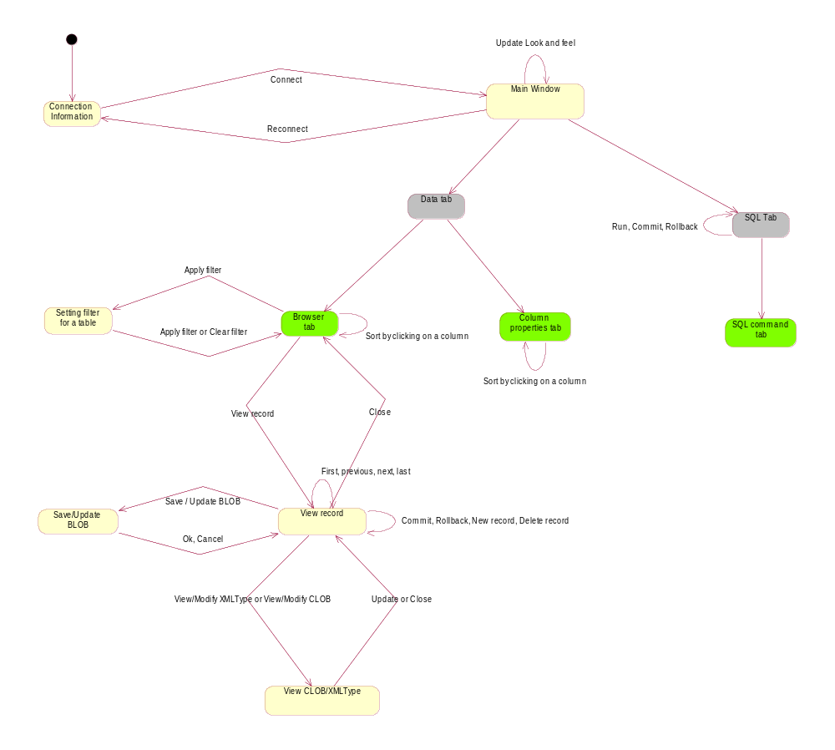

Legend:
- Boxes with round corners represent a user’s view of the system. The yellow boxes are windows and the grey boxes are tabs within the window. Green boxes are sub tabs within a tab
- Arrows represent a transition from one view to another. The name on the arrow is the name of the user action which triggers the transition

Main Window

Showing Data Browser tab

Menu bar
Tool bar
Table name(40 rows total, 20 filtered)Filtered and Sorted

Column 1Column 2Column 3

View Record
Apply filter
All the tables and views in the table space are shown as a tree. Expanding a tree shows columns in the table or view

Clicking on a table name shows all the data in the selected table or the properties of the columns in the table

Information shown
- Menu bar provides access to all the functionality available
- Tool bar provides a shortcut to common tasks
- Browser tab has 2 sub tabs – ‘Data’ and ‘Column properties’
- Tables and views are shown as a tree. If the Data tab is selected, then clicking on a table name shows all the data in the selected table. If the ‘Column properties’ tab is selected, then clicking on a table name shows the properties of columns in the selected table
- When the Data tab is selected, the name of the table is shown along with a count of the number of rows in the table. If any filter or sorting is applied, then the words ‘Filtered and sorted’ are shown
- ‘Column properties’ tab shows the properties (data type, nullable or not, and length) of each column in the selected table.

User actions
- Clicking on the ‘View Record’ button shows the current record in a popup window (SeeView Record window )
- Clicking on the ‘Apply filter’ button allows the user to set the filter for a table. The filter settings for a table is remembered after the user exits the application
- Clicking on the column names sorts the data on the basis of the column (sorting can be done for all data types except CLOBS, BLOBS and XMLTypes)

Column properties tab
Menu bar
Tool bar
Table name(40 rows total, 20 filtered)Filtered and Sorted

Column name Data typeSizeNullable

All the tables and views in the table space shown as a tree. Expanding a tree shows columns in the table or view

Clicking on a table name shows all the data in the selected table or the properties of the columns in the table

Information shown
- Properties of the columns of the selected table are shown
- The properties shown are: Column name, Data type, Size and Nullable

User actions
- The user can sort the properties by clicking on the column headers. The properties are sorted by Column name by default

SQL Tab

Open new SQL tab
Drop down list for SQL commands history
User types SQL here (SQL text area)
Column 1Column 2 Column 3 Column 4

Drop down list for table names
Drop down list for column names
Run
Commit
Rollback
View record

Information shown
- ‘SQL’ tab allows multiple tabs inside it. A new tab is created for every SQL statement run.
- The drop down list for SQL commands history remembers 10 previous SQL commands for 10 table spaces. This can be changed using the properties file. Example: User can store 200 previous SQL commands for 2 table spaces
- A text area allows the user to type the SQL statements
- There are two drop down lists. One list shows the list of all tables and views in the table space. The second list shows the list of all columns in the table selected by the first list.
- The results are shown in the form of a table.

User actions
- ‘Open SQL tab’ opens a new SQL tab inside the main SQL tab
- Buttons on tabs can be used to close SQL tabs within the main SQL tab
- The user can drag and drop the name of the table or column from the list to the SQL text area. The name of the table or the column is appended to the SQL statement.
- The user can run the SQL statement by clicking on the ‘Run’ button. If ‘Auto commit’ is off, the ‘Commit’ and ‘Rollback’ buttons become enabled and flash drawing the user’s attention to it.
- The user can choose to ‘Commit ‘or ‘Rollback ‘ the SQL command only if ‘AutoCommit’ is off. If ‘AutoCommit’ is on, the ‘commit’ and ‘rollback’ buttons are disabled.
- The results are shown in the form of a table. The user can sort the results by clicking on a column header.

View Record window

Column 1:

Column 2:

Column 3:

Column 4:

Column 5:

Column 6:

View/Modify CLOB
View/Modify XML Type
Save/Update BLOB
Column value
Column value
Column value
First
Previous
Next
Last
New record
Delete record
Commit
Record 29 of 50
Rollback
Close

Information shown
- The current record number is shown in ‘Record X of Y format’
- If column type is ‘Number’, ‘String’ or ‘Date’, the values of the data is shown opposite the name of the column
- For BLOBS, CLOBS and XMLTypes, a button is displayed.

User actions
- Clicking on the ‘View/Modify XMLType’, ‘View/Modify CLOB’ or ‘View /Modify BLOB’ button allows the user to view/modify the data. If the data type is CLOB, or XMLType, then the data in the String is shown. If the data type is BLOB, then the user is given the option to store the bytes in the BLOB to disc.
- Four navigation buttons allow the user to navigate around the list of rows.
- The user can click on the ‘New record’ or ‘Delete record’ to add a new record or to delete the current record. If ‘Auto commit’ is off, then the ‘Commit’ and ‘Rollback’ buttons are enabled and flash to draw the users attention to it.
- Clicking on the ‘View/Modify CLOB’ or the ‘View/Modify XMLType’ brings up another window which shows the String. The user can modify the contents and press ‘Update’.

Update
CLOB or XML type string is shown here
Close
View CLOB/XMLType

Connection Information window

NameTable spaceURLLast logged in

Connect

Table space:
URL:
JDBC Driver:
Username:
Password:

Connection details
New connection
Save changes
Delete connection
Known connections

Information shown
- Selecting the connection form a list of previously used connections in the ‘Known connections’ area selects the connection. The details of the selected connection are shown in the ‘Connection details’ area

User actions
- User can click on ‘Connect’ to connect to a database for which the connection details are stored
- User can use the ‘New connection’ button to setup a new connection. After the connection details are entered, the user clicks on the ‘Save changes’ button. The connection details appear in the ‘Known connections’ area. The user can then select the new connection and click on ‘Connect’ to connect to the database
- The user can click on the ‘Delete connection’ to delete the selected connection details
- The user can click on the column headers to sort the connection details. Default is sorting by ‘Last logged in column’

Setting filter for a table window

Column name
Text field for value
Add to filter
Clear selection
Filter values are displayed here
Apply filter
Clear filter

Information shown
- The drop down list contains the list of all the column names for the selected table
- Another drop down list contains operators. Possible values are: <, >, =, <>, <=, >=, Null and not null.
- A text field allows the user to type in the value to filter the records on
- The values for the filters are shown in the text area. The user can also manually type in the values for the filter

User actions
- User can click on the ‘Add to filter’ button to add the selection to the filter.
- User can click on the ‘Clear selection’ button to clear the selection
- User can click on the ‘Apply filter’ button to set the filter
- User can click on the ‘Clear filter’ button to clear all filters

Customise
The customise window is accessed through the toolbar or the menu bar

Start up tab

Show logo at start up

Connect at start up to

Show browser tab

Show Data tab

Show Column properties tab

Show SQL tab

OK
Apply
Cancel
Table space name

Information shown
- The customise window has 4 tabs:
  - Start up: Used to set the options which change the behaviour of the application at start up time
  - Engine: Used to set the options which change the way the engine works – currently the only option is to set the transaction level for batch run
  - Driver Manager: Used to add or remove a JDBC driver
  - Browser: Used to change the properties of ‘Data’ and ‘Column properties’ tab
  - SQL: Used to change the properties of the SQL tab

User actions
- User clicks on ‘OK’ or ‘Apply’ button to apply the changes
- User clicks on ‘Cancel’ button to quit without applying the changes

Driver Manager tab

NameLocation

Oracle driverc:\oracle\ojdbc14.jar

OK
Apply
Cancel
Add new JDBC driver
Delete selected driver

SQL tab

Store SQL commands for table spaces

Store previous commands for each table space

OK
Apply
Cancel
100
10

Export
The export window is accessed through the menu bar or the tool bar. It exports the results of the query as a PDF, XML, HTML or CSV file. The contents of the current window are exported.

Export contents as…
XML

CSV

HTML

PDF
Ok
Cancel

Information shown
- The user is presented with 4 check boxes. He can choose all or none of the options. When the user presses the ‘Ok’ button, he is prompted for a location to store the file to

Batch Run

The user can specify the batch file which contains a list of sql commands which are run together. The user is presented with a standard file chooser dialog box to choose the location of the file. The user can specify the character which is used to separate the sql statements (default is ‘;’).

The user can customise the batch run process via the customise tab. The user can specify whether to run each SQL statement as a separate transaction or to wrap the whole batch process in a single transaction.

Toolbar
The toolbar consists of the following shortcuts:
- Driver manager: Allows the user to specify the location of JDBC drivers used to connect to the Database
- Reconnect: Allows the user to connect to a different tablespace
- Commit and Rollback buttons: allow the user to commit or rollback the update to the database. They are enabled only if ‘AutoCommit’ is off.
- Refresh: Refresh the current view by reloading the data from the database. If the user has selected the ‘Browser’ tab, then the table contents are reloaded from the database. If the user has selected the ‘SQL’ tab, then the SQL query is run again
- Look and feel: The user can click this to change the look and feel. The UI is updated with the new look and feel
- Export: The user can click on this to export the contents of the current view as XML, CSV, HTML and PDF
- Customise: The user can click on this to set the various options to customise the application
- Batch run: The user can click on this button to specify the location of the batch file which contains a list of sql commands which are run together.

Driver Manager…
Reconnect…
Commit
Rollback
Refresh
Look and feel name
Apply
Export…
Customise…
Batch run…

Keyboard shortcuts

- Ctrl-C: Press Ctrl-C over a text area. It will copy the highlighted text
- Ctrl-X: Press Ctrl-X over a text area. It will cut the text
- Ctrl-V: Press Ctrl-V over a text area. It will paste the text (if any) into the text area
- Ctrl-A: Press Ctrl-V over a text area. It will select all the text in the text area
- F5: Press F5 in the ‘Browser’, ‘SQL’ or ‘Column properties’ tab. It will refresh the data by retrieving the data from the database. In the case of ‘SQL’ tab, it will re-run the SQL
- F1: Press F1 to open the help window. The topic relevant to the selected UI widget is selected in the help window. Example: The user is typing a value into a text box and the text box has focus. The user presses F1 key. The help information shown is relevant to the text box. The user can also right click on a UI widget and select ‘What is this’. In this case also the help window is opened which is relevant to the UI widget under the users mouse

Help window

Standard JavaHelp window is used to display help information. Only one Help window is shown. If the Help window is open and showing a help topic, the help window is updated and shows the new help topic. The Help window is shown when:

- The user right clicks on any UI widget and chooses ‘Help’ from the popup menu.
- The user chooses ‘Help -> Help’ from the menu bar

Context Sensitive Help is shown when:
- The user presses F1 over any UI widget
- The user right clicks on any UI widget and chooses ‘What is this’
- The user chooses ‘Help -> What is this’ from the menu bar

When context sensitive help is shown, the help information shown is relevant to the UI widget. Example: The user is typing a value into a text box and the text box has focus. The user presses F1 key. The help information shown is relevant to the text box.

